

# Phone Alert Systems for Landline Phones

Phone alert systems provide alerts via loud sounds, bright strobe lights; and/or strong vibrations that help notify deafblind persons and persons with visual impairment, hearing disabilities and cognitive disabilities of incoming and missed calls and messages.

These accessories might be helpful for persons with limited mobility as in some cases it can provide alerts for numerous devices around the home from one device.

**Type of accessory:** Phone alert systems

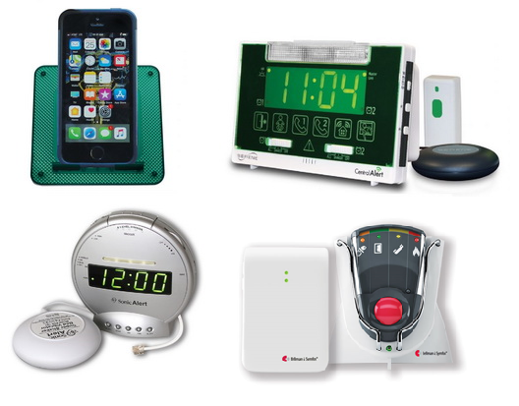

## How do you use these accessories?

Connect the phone alert system with your landline phone. Plug in any additional accessories or sensors and customise the alarm, vibration and light notification settings to your preference.

## These accessories connect to phones via:

Audio Jack: No

Bluetooth: Yes

Wi-Fi: No

Micro USB: No

Other: Yes - landline telephone cord

## Is there any other piece of equipment required for this accessory to work properly with a phone?

No, it does not require any additional equipment to connect or work properly with a landline phone.

## Compatibility:

These phone alert systems are compatible with landline telephones. Some are compatible with landline phones with Bluetooth capabilities.

## Popular Phone Alert Systems available in Australia:

### Serene Innovations RF-105 RingMaster Telephone Ringer – landline

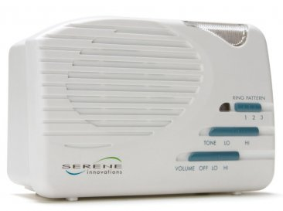

This loud ringer connects to your home telephone line and will alert you to the phone ringing with loud sound and light.

Features:

* Flashing light and loud ringer.
* You can add a vibrating bed shaker.
* Compatible with landline phones.

You can buy this accessory from [Phoenix Hearing](https://www.phoenixhearing.com.au/rf105.html) (requires sign in or sign up to view product range).

### Bellman & Symfon Telephone Transmitter with Portable Receiver – landline

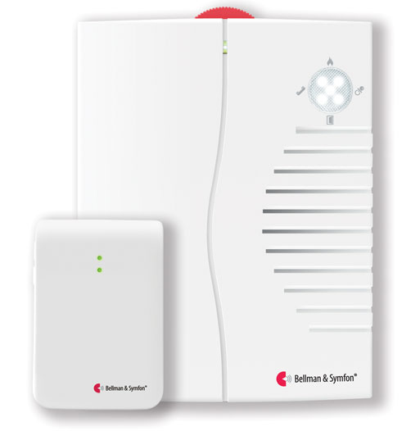

The Bellman Visit Telephone transmitter and Portable Receiver work together to ensure you never miss an incoming telephone call. The installation is extremely easy; simply plug the telephone transmitter into the telephone socket.

When there is an incoming call, the telephone transmitter sends a radio signal to the Bellman Visit Portable Receiver(s) to notify you with a loud sound signal and a bright light. It’s easy to use and wireless, so you can bring it around your home, out on the balcony or yard.

The Portable receiver has an optimised sound frequency and an adjustable sound level ranging from 0 dB up to 90 dB.

Features:

* Loud ringer (and a small flashing light).
* Compatible with landlines.

You can buy this device from [ClearaSound](https://clearasound.com.au/product/telephone-transmitter-portable-receiver/). Separate components can be purchased from [Hearing Connections](http://www.hearconnect.com.au/products) and [Word of Mouth Technology.](https://wom.com.au/be1033)

More information on:

[Telephone Transmitter with Portable Receiver Webpage](https://clearasound.com.au/product/telephone-transmitter-portable-receiver/)

### Bellman & Symfon Telephone Ringer – landline

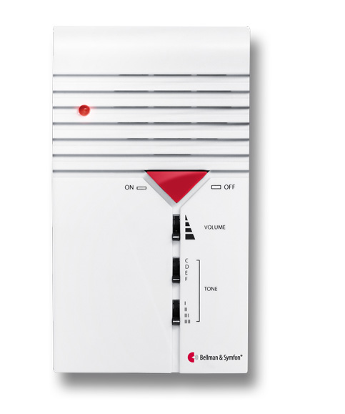

The Bellman Ringer will alert you with a powerful sound signal and a small LED indication when the telephone rings. You can easily adjust the ring volume, tone and sound pattern to suit your individual needs. It simply plugs into your telephone line.

Features:

* Loud ringer
* Compatible with landlines.

You can buy this accessory from [ClearaSound](https://clearasound.com.au/product/bellman-telephone-ringer/) and [Word of Mouth Technology.](https://wom.com.au/visit)

More information on:

[Telephone Ringer Webpage](https://clearasound.com.au/product/bellman-telephone-ringer/)

### Telstra Extension Ringer / General Purpose Alarm – landline

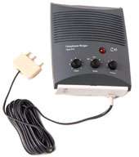

The Extension Ringer / General Purpose Alarm is an auxiliary telephone ringer that can be installed in conjunction with your standard telephone to provide additional ring volume for people with a hearing impairment.

It allows you to adjust the ring pitch and volume, and it can be plugged into any socket, no batteries or mains power required on the current model.

Features:

* Loud ringer
* Compatible with landline phones.

This accessory is available under [Telstra’s Disability Equipment Program](https://www.telstra.com.au/aboutus/community-environment/community-programs/disability/disability-equipment-program#acc-accessories), you need to:

* Have a disability or impairment that means you're unable to use a standard telephone handset
* Be a Telstra retail customer or an associate of a Telstra retail customer (eg. a household member or small business employee) that has a basic phone line service and rents a phone from Telstra.

More information on:

[Telstra Disability Equipment Webpage](https://www.telstra.com.au/aboutus/community-environment/community-programs/disability/disability-equipment-program#acc-accessories)

[Telstra Disability Equipment Brochure (PDF Download)](https://www.telstra.com.au/content/dam/tcom/about-us/community-environment/pdf/disability-equipment-program-d036-1214.pdf)

### Serene Innovations CentralAlert Wireless Tabletop Home Notification System CA-360 – landline

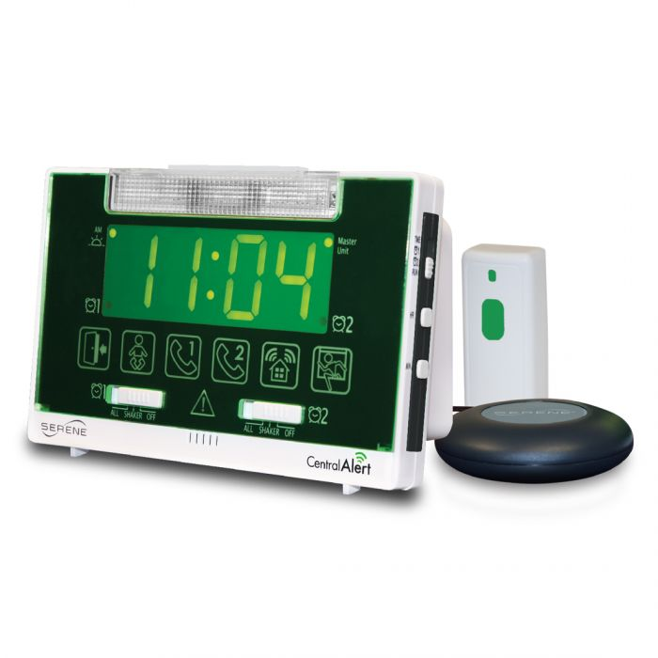

This home notification system gives instant alerts for incoming landline phone calls and doorbell rings, and comes with a built-in alarm clock. Its alerts include a bright flashing light, adjustable alarm sounds, large onscreen icons and a vibrating bed shaker. The device can be linked to two landline phone lines and has a range of up to 60 metres. It can be paired with a smartphone to provide alerts for calls and messages via the Serene Innovations CA-CX.

Features:

* Flashing light, loud ringer and vibrating bed shaker.
* Compatible with landline phones, requires additional accessory for mobile phones.

You can buy this accessory from[Phoenix Hearing](https://www.phoenixhearing.com.au/StoreXCart/) (requires sign in or sign up to view product range).

More information on:

[Home Notification System CA-360 Phoenix Australia](https://www.phoenixhearing.com.au/centralalert.html)

[Home Notification System CA-360 USA Manufacturer's Webpage](https://www.sereneinnovations.com/products/home-alert-systems/centralalerttm-wireless-tabletop-home-notification-systems.html)

[Home Notifications System CA-360 User Manual (PDF Download)](https://www.sereneinnovations.com/pub/media/sebwite/productdownloads/5/3/53operatingguide.pdf)

[Home Notification System Video Tutorials](https://www.youtube.com/playlist?list=PL9A081A2A73E66A6A)

### Sonic Alert Sonic Bomb Phone Signaller SBT425ss – landline

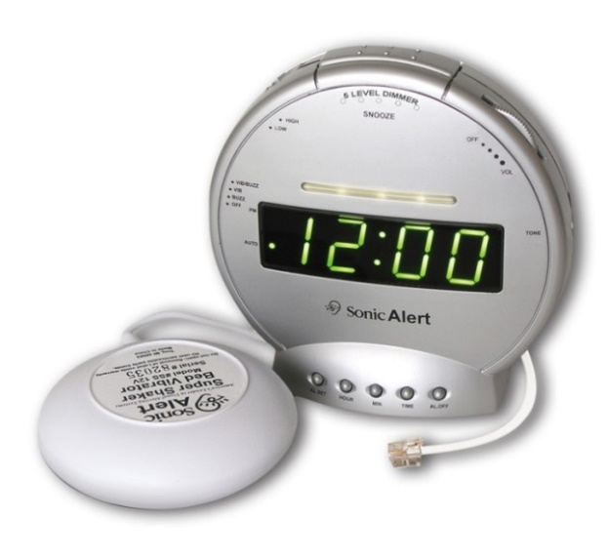

This alarm clock features an extra loud alarm, flashing lights and a vibrating bed shaker that signal incoming telephone calls or programmed alarms. The alarm has volume and tone controls and can reach 113dB, and the lights and vibrator can be adjusted to preference. This accessory can only be paired with a landline, not a mobile phone.

Features:

* Flashing light, loud ringer and vibrating bed shaker.
* Compatible with landline phones.

You can buy this accessory from [Phoenix Hearing](https://www.phoenixhearing.com.au/StoreXCart/) (requires sign in or sign up to view product range).

More information at:

[Sonic Bomb Phone Signaller SBT425ss USA Manufacturer’s Webpage](https://sonicalert.com/SBT425SS-Alarm-Clock)

[Sonic Boom Phone Signaller SBT425ss User Manual (PDF Download)](https://system.na1.netsuite.com/core/media/media.nl?id=18601&c=4555569&h=b26babab3e11cba13b6f&_xt=.pdf)

[Sonic Boom Phone Signaller SBT425ss Video Tutorial](https://www.youtube.com/watch?v=BK5NrsKReMg)

### Bellman & Symfon Telephone Transmitter with Visit Alarm Clock – landline

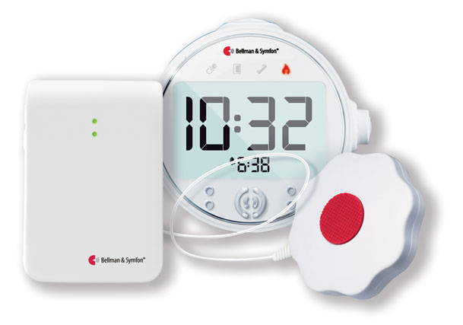

Combining the Visit Telephone Transmitter with the Visit Alarm Clock, ensures individuals with hearing impairments or deep sleepers will be alerted of incoming calls, using the option of an amplified alarm, LED flashing light and or vibrating pad.

The installation is extremely easy; simply plug the Telephone transmitter into the telephone socket. When activated by an incoming telephone call, the telephone transmitter sends a radio signal to the Bellman™ Visit Clock for alerting.

Features:

* Flashing light, loud ringer and vibrating bed shaker
* Compatible with landlines.

You can buy this device from [ClearaSound](https://clearasound.com.au/product/telephone-transmitter-with-visit-clock/). Separate components can be purchased from [Hearing Connections](http://www.hearconnect.com.au/products) and [Word of Mouth Technology.](https://wom.com.au/visit)

More information on:

[Telephone Transmitter with Visit Alarm Clock Webpage](https://clearasound.com.au/product/telephone-transmitter-with-visit-clock/)

### Bellman & Symfon Telephone Transmitter with Flash – landline

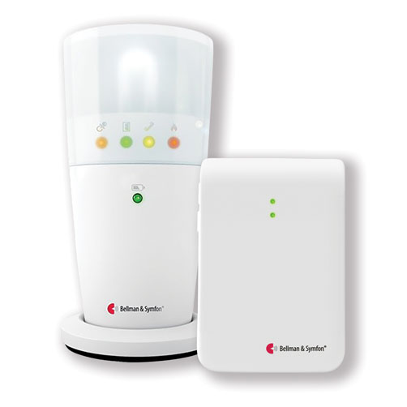

The Bellman Visit Telephone Transmitter is the part of the Bellman™ Visit system that alerts you to incoming telephone calls. It features easy installation, by simply plugging the Telephone transmitter into the telephone socket. When activated by an incoming telephone call, the Telephone transmitter sends a radio signal to the Flash receiver for alerting.

When disconnecting the telephone cord the Telephone transmitter (“Multipurpose transmitter”) can also be used as a Push-button transmitter or pager.

Features:

* Flashing light
* Compatible with landline phones.

You can buy this device from [ClearaSound](https://clearasound.com.au/product/bellman-telephone-transmitter-with-flash/). Separate components can be purchased from [Hearing Connections](http://www.hearconnect.com.au/products) and [Word of Mouth Technology.](https://wom.com.au/visit)

More information on:

[Telephone Transmitter with Flash Webpage](https://clearasound.com.au/product/bellman-telephone-transmitter-with-flash/)

### Bellman & Symfon Telephone Transmitter with Pager & Charger – landline Bellman & Symfon Telephone Telephone Transmitter with Pager & Charger

The Visit telephone transmitter is part of the Visit smart home system that helps alert you to incoming calls. It signals the pager with vibrations and a lighted symbol when the telephone transmitter is being activated. The pager is small, light-weight and can be carried in your pocket or on your belt.

The Pager Charger is specially designed for the Visit smart home system and is used to recharge the Visit pager battery when powered by a rechargeable battery.

By adding the Bellman™ Bedshaker to this package, and connecting it to the Pager Charger, you can also be alerted to incoming calls whilst you are in bed.

Features:

* Vibrating pager
* Compatible with landline phones.

You can buy this device from [ClearaSound](https://clearasound.com.au/product/telephone-transmitter-pager-charger/). Separate components can be purchased from [Hearing Connections](http://www.hearconnect.com.au/products) and [Word of Mouth Technology.](https://wom.com.au/visit)

More information on:

[Telephone Transmitter with Pager & Charger Webpage](https://clearasound.com.au/product/telephone-transmitter-pager-charger/)

### Bellman & Symfon Mobile & Telephone Night Alert Package – landline and mobile



By placing the Bellman Mobile Sensor on top of the mobile device you will be alerted of an incoming call or message by the Bellman Visit Clock alert with sound, flashes or vibrations.

The Bellman Mobile Phone Sensor is connected to the Bellman™ Telephone/Multi-purpose Transmitter, which is directly plugged into the telephone line, ensuring you never miss any calls by sending a signal to the Visit Alarm clock.

Package includes the Bellman™ Visit Alarm Clock with Bed Shaker, Telephone/Multi-purpose Transmitter and Mobile Phone Sensor.

Features:

* Flashing light, loud ringer and vibrating bed shaker.
* Compatible with landline and mobile phones.

You can buy this device from [ClearaSound](https://clearasound.com.au/product/mobile-landline-night-alert-package/). Separate components can be purchased from [Hearing Connections](http://www.hearconnect.com.au/products) and [Word of Mouth Technology.](https://wom.com.au/visit)

More information on:

[Mobile & Telephone Night Alert Package Webpage](https://clearasound.com.au/product/mobile-landline-night-alert-package/)

### Bellman & Symfon Mobile & Telephone Day Alert Package – landline and mobile

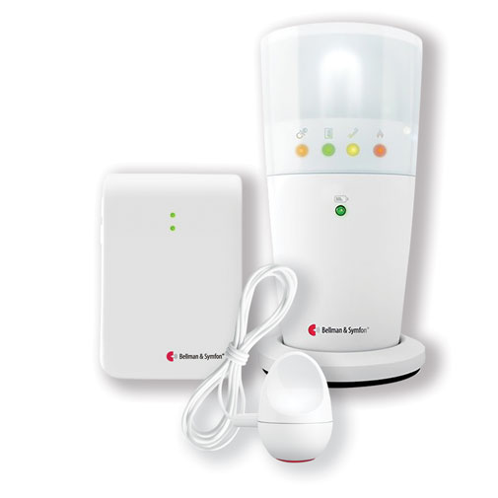

This package allows you to never miss a call or text on your mobile or landline during the day. The Bellman Mobile Phone Sensor is activated when a mobile phone or tablet screen lights up, for example from an incoming call or message from your mobile.

The mobile Phone Sensor is connected to the Bellman Telephone/Multi-Purpose Transmitter which is directly plugged into the telephone line ensuring you never miss any calls. The Bellman Flash Receiver will respond to the Telephone/Multi-Purpose Transmitter alerting you (by flashing) that someone is trying to reach you.

Package includes the Bellman Visit Flash Receiver, Telephone/Multi-Purpose Transmitter and Mobile Phone Sensor

Features:

* Flashing light
* Compatible with landline and mobile phones

You can buy this device from [ClearaSound](https://clearasound.com.au/product/mobile-landline-day-alert-package/). Separate components can be purchased from [Hearing Connections](http://www.hearconnect.com.au/products) and [Word of Mouth Technology.](https://wom.com.au/visit)

More information on:

[Mobile & Telephone Day Alert Package Webpage](https://clearasound.com.au/product/mobile-landline-day-alert-package/)

### Bellman & Symfon Mobile & Telephone Vibrating Alert – landline and mobile

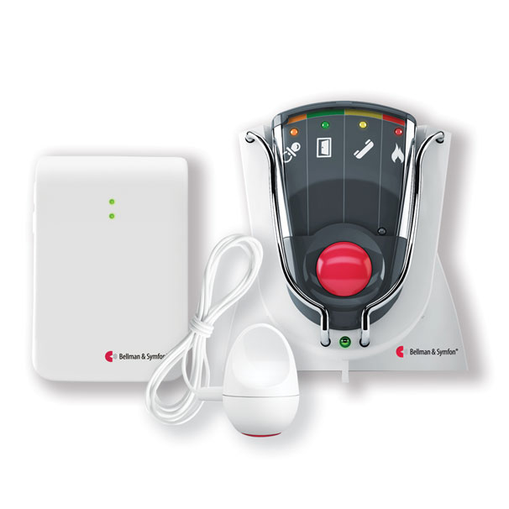

This package allows you to never miss a call or text from your mobile or landline during the day by wearing the Bellman Visit Pager. Simply clip the pager to your clothing, and it will respond to the Bellman™ Telephone/Multi-Purpose Transmitter or Bellman™ Mobile Phone Sensor, alerting you, by vibrating, that someone is trying to reach you. The pager is small, lightweight and can be carried in your pocket or on your belt.

The Mobile Phone Sensor is activated when a mobile phone or tablet screen lights up, for example from an incoming call or message from your mobile. The Mobile Phone Sensor must be connected to the Telephone/Multi-Purpose Transmitter to operate.

If you wish to also be alerted to incoming calls on your regular phone simply plug the telephone line into the Telephone/Multi-Purpose Transmitter ensuring you never miss any calls.

Features:

* Vibrating pager
* Compatible with landline and mobile phones.

You can buy this device from [ClearaSound](https://clearasound.com.au/product/mobile-telephone-vibrating-alert/). Separate components can be purchased from [Hearing Connections](http://www.hearconnect.com.au/products) and [Word of Mouth Technology.](https://wom.com.au/visit)

More information on:

[Mobile & Telephone Vibrating Alert Webpage](https://clearasound.com.au/product/mobile-telephone-vibrating-alert/)

### Serene Innovations Central Alert Home – landline and mobile

*Also known as: Cell Phone Sensor-Transmitter CA-CX*

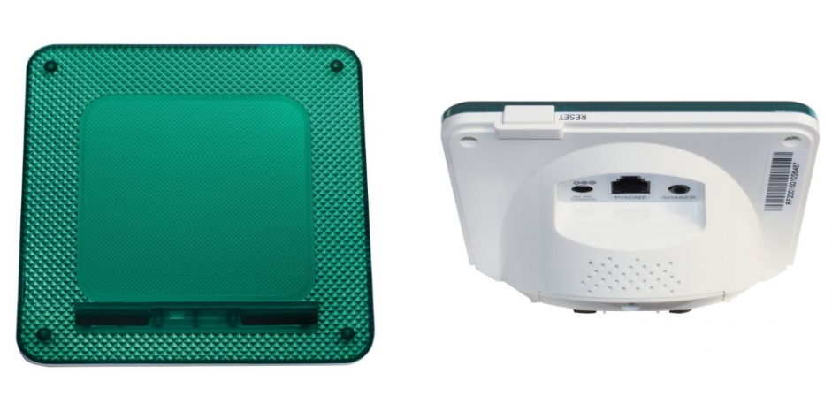

This phone alert system uses flashing light patterns and adjustable ringtones to alert and distinguish between incoming phone calls, video calls and texts for a landline and mobile phone devices. Any missed mobile phone calls will also cause the lights to flash.

Simply plug your home phone into this accessory. It features a volume control switch and USB port that can be used to charge mobile phones and other electronic devices.

Features:

* Flashing light and loud ringer
* Compatible with landline and mobile phones.

You can buy this accessory from [Phoenix Hearing](https://www.phoenixhearing.com.au/cacx.html) (requires sign in or sign up to view product range).

More information on:

[Home/Cell Phone Sensor-Transmitter CA-CX USA manufacturer's Web](https://www.sereneinnovations.com/products/home-alert-systems/centralalerttm-home-cell-phone-sensor-transmitter.html)page

[Home/Cell Phone Sensor-Transmitter CA-CX User Manual (PDF Download)](https://www.sereneinnovations.com/pub/media/sebwite/productdownloads/c/a/ca-cx_ug_rev2_2015.pdf)

### Serene Innovations Super-Loud Home/Cell Phone Ringer and Flasher RF-200 – landline and mobile

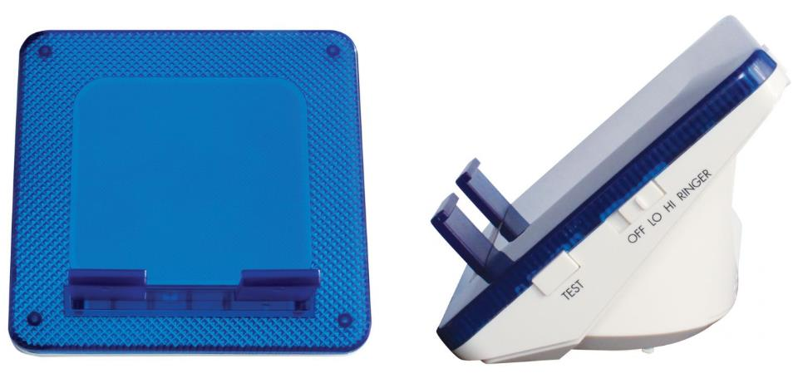

This phone alert system uses flashing light patterns and adjustable ringtones to alert and distinguish incoming phone calls, video calls and texts for a landline or mobile phone device.

Plug your home phone into the accessory or rest your mobile phone on the accessory in vibrate mode. The device features a USB port to charge your phone and a volume control switch.

Features:

* Flashing light and loud ringer
* Compatible with landlines and mobile phones.

You can buy this accessory from [Phoenix Hearing](https://www.phoenixhearing.com.au/rf200.html) (requires sign in or sign up to view product range).

More information on:

[Super-Loud Home/Cell Phone Ringer and Flasher RF-200 USA manufacturer's Webpage](https://www.sereneinnovations.com/products/home-alert-systems/super-loud-home-cell-phone-ringer-flasher.html)

[Super-Loud Home/Cell Phone Ringer and Flasher RF-200 User Manual (PDF Download)](https://www.sereneinnovations.com/pub/media/sebwite/productdownloads/r/f/rf-200_v2_manual_ol_e_f_9-4-2014.pdf)